HC 2 T3 U1
 | 題目 | 圖片
1 | I see a bird. | 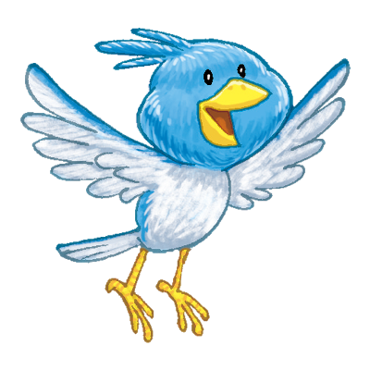
2 | I see a frog. | 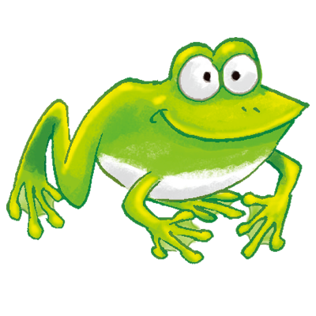
3 | I see a turtle. | 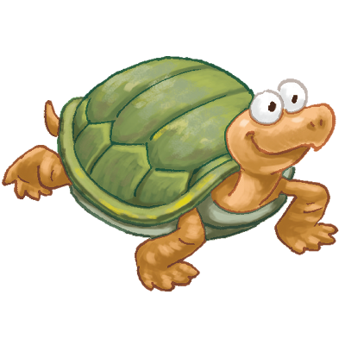
4 | I see a duck | 



